THE REVERSE PARALLEL PARK
Throughout the driving test, the examiner will ask you to park on the left on more than one occasion. This is to ensure you do so safely by using the main interior mirror, your left mirror, signalling to the left and having a quick look over your left shoulder before you move to the left. The examiner will not ask you to park anywhere that is illegal, although do ensure to avoid parking in front of somebody's driveway, or a fire hydrant. Once you have stopped the car, apply the handbrake and select Park. Other than testing your ability to park safely on the left, it may be to perform a driving test manoeuvre such as the Reverse Parallel Park.
The examiner will provide a briefing that they wish you to demonstrate the reverse parallel park on the car in front, shown in A. Whilst moving off to get position for this manoeuvre, move off slowly so as to get an ideal and accurate position. The examiner allows plenty of time for manoeuvres, so don’t rush. As you are about to pull alongside the target vehicle, check your interior and left mirror. Ideally, stop a little ahead of the target vehicle (around half a car length) and around half of a metre to 1 metre maximum from the side of the target vehicle. Once stopped, remember to cancel your indicator if you applied it. Now select reverse gear . If there are any approaching vehicles, cyclists or pedestrians, stop, put your hazard lights on and wait for approaching activity to pass.
Once you are happy it is all clear, look in the direction that the car is travelling, which is out of the rear window, then proceed to move the car backwards. Keep the car very slow. Think of a slow walking pace to give you an idea.  You will now need to get the rear wheels of your car, level with the rear bumper of the target vehicle. Set yourself some reference points to help. Know where on the inside of your car the rear wheels are, say, directly under the back parcel shelf. It is better to go a little too far back than not enough. Not going far enough back may result in your car turning into the car you intend on parking behind if you are not careful. Establishing and getting confident with your reference points is important and will help with this manoeuvre.  Keep the car very slow as you will need to constantly look around in all directions and be accurate with your reference points. Once you are happy with positioning, stop the car. Your car is now at its point-of-turn. At the point-of-turn you will steer rapidly to the left while moving the car in reverse very slowly, the front of your car will swing out into the road. This is the most hazardous part of the manoeuvre. Before moving the car or steering, take all round effective observation. This includes your right blind spot in case there maybe cyclists you can't see in the mirrors for example.  If you are happy it is all clear, look in the direction the car is travelling (out the rear windscreen) and very slowly move the car backwards. Just as you move the car, steer full lock to the left. At the point where your forward angle is approximately 45 degrees to the road direction, stop the car. You will now need to establish the next reference point. This is the point in which you steer to the right to straighten the car.  This reference point can vary from car to car, but to give an idea of what usually works, line the left corner of your car up with the right corner of the car you are parking behind. At this point, steer full right lock. Another example may be to use your left mirror and when the kerb in the mirror gets to a certain point (usually about to disappear from view), that's the time to right lock the steering. . This will bring the car in parallel to the kerb. Whichever reference point you use, once you reach it, stop. By stopping at each reference point, you are breaking down the manoeuvre to a step-by-step process, allowing you to look around more, slowing the whole process down.  Whenever you are reversing a car, you will need constant all-round observation and likely needing to stop if any vehicles approach at this point. Also if you are reversing towards pedestrians, stop, allow them to pass before proceeding. Don't forget to make frequent checks out the rear windscreen. Also don’t forget to activate your hazard lights as needs be in these circumstances. | 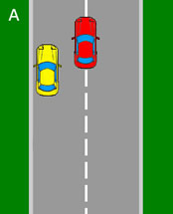
 | 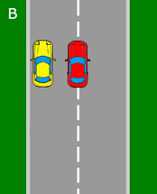
 | 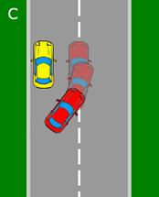
 | 